# Database Basics MS SQL Exam – 13 February 2021

Exam problems for the [“Database Basics” course @ SoftUni](https://softuni.bg/courses/databases-basics-ms-sql-server).

Submit your solutions in the SoftUni Judge system at <https://judge.softuni.bg/>

# Bitbucket

You’ve most likely heard of Github. Well … There is a side project called “Bitbucket” which is the back-up data of Github. You are one of the few selected to work in the multi-billion company, as one of the back-up database managers. You’ll need to prove your skills by designing and manipulating data in the Instagraph prototype.

# Section 1. DDL (30 pts)

You are given an E/R Diagram of the Trip Service:

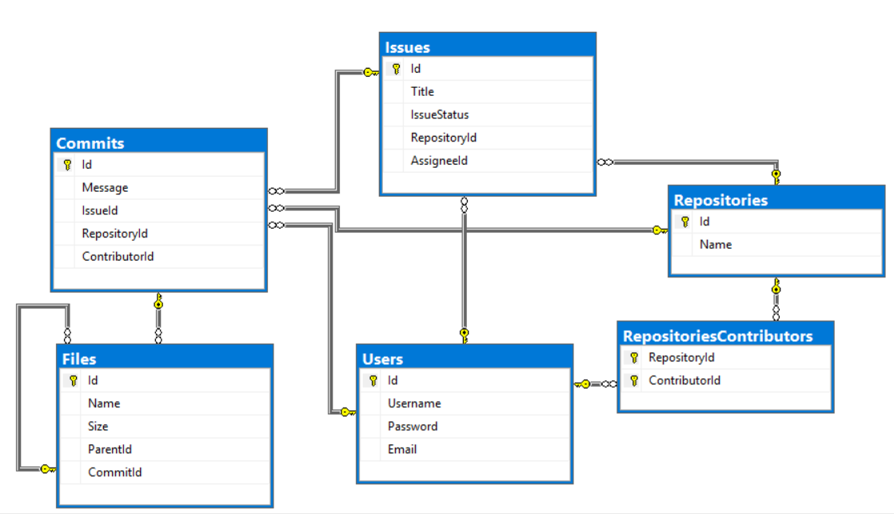

Crеate a database called Bitbucket. You need to create **6 tables**:

* Users – contains information about the **users**.
* Repositories – contains information about the **repositories**.
* RepositoriesContributors – a **many** to **many** **mapping** table between the **repositories** and the **users**.
* Issues – contains information about the **issues**.
  + Each issue has a repository.
  + Each issue has an assignee (user).
* Commits – contains information about the **commits**.
  + Each commit **MAY** have an issue.
  + Each commit has a repository.
  + Each commit has a contributor (user).
* Files – contains information about the files.
  + Each file MAY have a parent (file).
  + Each file has a commit.

**Users**

|  |  |  |
| --- | --- | --- |
| **Column Name** | **Data Type** | **Constraints** |
| Id | **Integer** from **0** to **2,147,483,647** | Unique table **identificator**, **Identity** |
| Username | **String** up to 30 symbols | **NULL** is **not** allowed |
| Password | **String** up to 30 symbols | **NULL** is **not** allowed |
| Email | **String** up to 50 symbols | **NULL** is **not** allowed |

**Repositories**

|  |  |  |
| --- | --- | --- |
| **Column Name** | **Data Type** | **Constraints** |
| Id | **Integer** from **0** to **2,147,483,647** | Unique table **identificator**, **Identity** |
| Name | **String** up to 50 symbols | **NULL** is **not** allowed |

**RepositoriesContributors**

|  |  |  |
| --- | --- | --- |
| **Column Name** | **Data Type** | **Constraints** |
| RepositoryId | **Integer** from **0** to **2,147,483,647** | **NULL** is **not** allowed, Relationship with table Repositories |
| ContributorId | **Integer** from **0** to **2,147,483,647** | **NULL** is **not** allowed, Relationship with table Users |

**Issues**

|  |  |  |
| --- | --- | --- |
| **Column Name** | **Data Type** | **Constraints** |
| Id | **Integer** from **0** to **2,147,483,647** | Unique table **identificator**, **Identity** |
| Title | **String** up to 255 symbols | **NULL** is **not** allowed |
| IssueStatus | **String** with **exactly 6** symbols | **NULL** is **not** allowed |
| RepositoryId | **Integer** from **0** to **2,147,483,647** | **NULL** is **not** allowed, Relationship with table Repositories |
| AssigneeId | **Integer** from **0** to **2,147,483,647** | **NULL** is **not** allowed, Relationship with table Users |

**Commits**

|  |  |  |
| --- | --- | --- |
| **Column Name** | **Data Type** | **Constraints** |
| Id | **Integer** from **0** to **2,147,483,647** | Unique table **identificator**, **Identity** |
| Message | **String** up to 255 symbols | **NULL** is **not** allowed |
| IssueId | **Integer** from **0** to **2,147,483,647** | Relationship with table Issues |
| RepositoryId | **Integer** from **0** to **2,147,483,647** | **NULL** is **not** allowed, Relationship with table Repositories |
| ContributorId | **Integer** from **0** to **2,147,483,647** | **NULL** is **not** allowed, Relationship with table Users |

**Files**

|  |  |  |
| --- | --- | --- |
| **Column Name** | **Data Type** | **Constraints** |
| Id | **Integer** from **0** to **2,147,483,647** | Unique table **identificator**, **Identity** |
| Name | **String** up to 100 symbols | **NULL** is **not** allowed |
| Size | **Decimal** number with **two-digit** precision | **NULL** is **not** allowed |
| ParentId | **Integer** from **0** to **2,147,483,647** | Relationship with table Files |
| CommitId | **Integer** from **0** to **2,147,483,647** | **NULL** is **not** allowed, Relationship with table Commits |

**N.B: Use VARCHAR for strings, not NVARCHAR! Keep in mind that Judge doesn’t accept “ALTER” statement and square brackets naming, when the names are not keywords.**

## Database Design

Submit all of yours **create** **statements** to Judge (only creation of tables).

# Section 2. DML (10 pts)

**Before you start, you must import “**DataSet-Bitbucket.sql**”. If you have created the structure correctly, the data should be successfully inserted without any errors.**

In this section, you have to do some data manipulations:

## Insert

**Insert** some sample data into the database. Write a query to add the following records into the corresponding tables. **All Ids should be auto-generated**.

**Files**

|  |  |  |  |
| --- | --- | --- | --- |
| Name | Size | ParentId | CommitId |
| Trade.idk | 2598.0 | 1 | 1 |
| menu.net | 9238.31 | 2 | 2 |
| Administrate.soshy | 1246.93 | 3 | 3 |
| Controller.php | 7353.15 | 4 | 4 |
| Find.java | 9957.86 | 5 | 5 |
| Controller.json | 14034.87 | 3 | 6 |
| Operate.xix | 7662.92 | 7 | 7 |

**Issues**

|  |  |  |  |
| --- | --- | --- | --- |
| Title | IssueStatus | RepositoryId | AssigneeId |
| Critical Problem with HomeController.cs file | open | 1 | 4 |
| Typo fix in Judge.html | open | 4 | 3 |
| Implement documentation for UsersService.cs | closed | 8 | 2 |
| Unreachable code in Index.cs | open | 9 | 8 |

## Update

Make issue status 'closed' where Assignee Id is 6.

## Delete

Delete repository "**Softuni-Teamwork**" in repository **contributors** and **issues**.

# Section 3. Querying (40 pts)

**You need to start with a fresh dataset, so recreate your DB and import the sample data again (**DataSet-Bitbucket.sql**).**

## Commits

Select all commits from the database. Order them by **id** (ascending), **message** (ascending), **repository id** (ascending) and **contributor id** (ascending).

### Examples

|  |  |  |  |
| --- | --- | --- | --- |
| **Id** | **Message** | **RepositoryId** | **ContributorId** |
| 1 | Deleted deprecated functionality from index.cpp | 17 | 8 |
| 2 | Created README.MD | 14 | 8 |
| 3 | Initial Commit | 24 | 1 |
| 4 | Implemented config.json functionality | 10 | 12 |
| … | … | … | … |

## Front-end

Select all of the **files**, which have **size, greater** than **1000**, and a **name** containing "html". Order them by **size** (descending), **id** (ascending) and by **file name** (ascending).

### Examples

|  |  |  |
| --- | --- | --- |
| **Id** | **Name** | **Size** |
| 49 | compile.html | 27402.59 |
| 17 | Login.html | 2863.23 |
| … | … | .. |

## Issue Assignment

Select all of the issues, and the users that are **assigned** to them, so that they end up in the following format: {**username**} : {**issueTitle**}. Order them by **issue id** (descending) and **issue assignee** (ascending).

### Examples

|  |  |
| --- | --- |
| **Id** | **IssueAssignee** |
| 75 | TheDivineBel : Critical bug in Controller.php ruins application when executed |
| 74 | DarkImmagidsa : Compilation failed while trying to execute init.xml |
| 73 | ScoreAntigarein : Loose Cohesion and Strong Coupling in Beat.html |
| … | … |

## Single Files

### Examples

Select all of the **files**, which are NOT a **parent** to any other file. Select their size of the file and add "**KB**" to the end of it. Order them file **id** (ascending), **file name** (ascending) and **file size** (descending).

|  |  |  |
| --- | --- | --- |
| **Id** | **Name** | **Size** |
| 6 | Controller.json | 14034.87KB |
| 12 | Model.MD | 4753.67KB |
| 17 | Login.html | 2863.23KB |
| … | … | .. |

## Commits in Repositories

Select the **top 5** repositories in terms of **count** of **commits**. Order them by **commits count** (descending), **repository id** (ascending) then by **repository name** (ascending).

### Examples

|  |  |  |
| --- | --- | --- |
| **Id** | **Name** | **Commits** |
| 1 | WorkWork | 20 |
| 7 | DundaApp | 16 |
| 10 | SortedTupleJS | 12 |
| … | … | .. |

## Average Size

Select all users which have **commits**. Select their username and average size of the file, which were uploaded by them. Order the results by **average upload size** (descending) and by **username** (ascending).

### Examples

|  |  |
| --- | --- |
| **Username** | **Size** |
| RoundInspecindi | 19506.877500 |
| BlaAntigadsa | 18397.434000 |
| … | … |

# Section 4. Programmability (20 pts)

## All User Commits

Create a **user defined function**, named **udf_AllUserCommits(@username)** that receives a username.

The function must return count of all commits for the user:

### Example:

|  |
| --- |
| **Query** |
| **SELECT dbo.udf_AllUserCommits('UnderSinduxrein')** |
| **Output** |
| **6** |

## Search for Files

Create a **user defined stored procedure**, named **usp_SearchForFiles(@fileExtension)**, that receives files extensions.  
The procedure must print the **id**, **name** and **size** of the file. Add "**KB**" in the end of the size. Order them by **id** (ascending), **file name** (ascending) and **file size** (descending)

### Example:

|  |  |  |
| --- | --- | --- |
| **Query** | | |
| **EXEC** **usp_SearchForFiles** **'txt'** | | |
| **Output** | | |
| **Id** | **Name** | **Size** |
| 28 | Jason.txt | 10317.54KB |
| 31 | file.txt | 5514.02KB |
| 43 | init.txt | 16089.79KB |